SOFTWARE REQUIREMENTS SPECIFICATION
Team Collaboration & Task Management Hub

Prepared by:
Jean Pierre Ndikumana
Internship Project Assignment
Version: 1.1
Date: May 2026
Status: Draft — Pending Approval

Technology Stack
Backend: Node.js + Express.js | Frontend: React.js + Vite | Database: MySQL
Real-time: Socket.io | Auth: JWT + bcrypt | UI: Tailwind CSS

Table of Contents
Table of Contents 2
1. Introduction 4
1.1 Purpose 4
1.2 Scope 4
1.3 Definitions and Abbreviations 4
1.4 Overview 5
2. Overall Description 5
2.1 System Overview 5
2.2 User Roles and Permissions 5
2.3 Operating Environment 6
2.4 Assumptions and Dependencies 6
3. System Modules 6
4. Functional Requirements 6
4.1 Authentication Module 6
FR-AUTH-001: User Registration 6
FR-AUTH-002: User Login 7
FR-AUTH-003: Token-Based Authorization 7
FR-AUTH-004: Logout 7
FR-AUTH-005: Role Assignment 7
4.2 User & Team Management 7
FR-USER-001: View and Edit Profile 7
FR-USER-002: Admin User Management 7
FR-TEAM-001: Create Team 7
FR-TEAM-002: Add/Remove Team Members 7
FR-TEAM-003: Team Roles 7
4.3 Project Management 7
FR-PROJ-001: Create Project 7
FR-PROJ-002: Project Status 7
FR-PROJ-003: Project Boards 7
FR-PROJ-004: Project Archive 8
4.4 Task Management 8
FR-TASK-001: Create Task 8
FR-TASK-002: Kanban Drag & Drop 8
FR-TASK-003: Task Comments 8
FR-TASK-004: Task Attachments 8
FR-TASK-005: Task Filtering 8
FR-TASK-006: Task Search 8
4.5 Real-time Features 8
FR-RT-001: Live Board Updates 8
FR-RT-002: Real-time Activity Feed 8
FR-RT-003: Notifications 8
4.6 Admin Dashboard & Reporting 8
FR-ADMIN-001: User Overview 8
FR-ADMIN-002: Task Completion Report 8
FR-ADMIN-003: Team Productivity 9
5. Non-Functional Requirements 9
6. Use Cases 9
Use Case UC-01: User Login 10
Use Case UC-02: Create and Assign a Task 10
Use Case UC-03: Move Task Across Kanban Board 10
Use Case UC-04: Admin Manages Users 11
7. Database Design (MySQL) 11
7.1 Overview 11
7.2 Table Descriptions 11
Table: users 11
Table: teams 12
Table: tasks 12
7.3 Key Relationships 13
8. System Architecture 13
8.1 Component Overview 13
8.2 Backend Folder Structure 14
8.3 Frontend Folder Structure 14
9. Constraints and Assumptions 14
9.1 Technical Constraints 14
9.2 Project Constraints 14
9.3 Acceptance Criteria Summary 14
10. Data Flow Diagrams (DFDs) 15
10.1 Context Diagram (Level 0 DFD) 15
External Entities and Their Interactions 16
10.2 Level 1 DFD 16
Process Descriptions — Level 1 17
Data Store Reference — Level 1 18
10.3 Level 2 DFD — Process 4.0: Task Management 18
Sub-Process Descriptions — Level 2 19
11. Entity Relationship Diagram (ERD) 20
11.1 Entities and Attributes Summary 21
11.2 Relationship Descriptions 21
11.3 MySQL Foreign Key Constraints 22
Appendix A: Revision History 22
Appendix B: Document Approval 22

1. Introduction

1.1 Purpose
This Software Requirements Specification (SRS) document defines the functional and non-functional requirements for the Team Collaboration and Task Management Hub — a full-stack web application developed as part of an internship project assignment. This document serves as the official agreement between the developer and the project supervisor regarding system behavior, features, and constraints.
The SRS is intended for: the developer (Jean Pierre Ndikumana), the project supervisor/client, any future developers who maintain or extend the system.

1.2 Scope
The Team Collaboration and Task Management Hub (hereafter referred to as "the System") is a lightweight, real-time web application inspired by tools such as Trello and Asana. The system enables teams to:
- Create and manage projects with Kanban-style task boards
- Assign tasks to team members with deadlines and priorities
- Track task progress in real-time using WebSocket technology
- Communicate through task comments and a live activity feed
- Manage users, teams, and permissions through role-based access control

1.3 Definitions and Abbreviations
Term / Acronym | Definition
SRS | Software Requirements Specification — this document
API | Application Programming Interface — a set of endpoints the backend exposes
REST | Representational State Transfer — an architectural style for building APIs
JWT | JSON Web Token — a secure, self-contained token used for authentication
WebSocket | A protocol enabling full-duplex, real-time communication between client and server
Kanban | A visual project management method using columns to represent workflow stages
RBAC | Role-Based Access Control — restricting system access based on user roles
ORM | Object-Relational Mapper — a tool to interact with databases using code objects
UI/UX | User Interface / User Experience

1.4 Overview
This document is organized as follows:
- Introduction — purpose, scope, definitions
- Overall Description — system context, user roles, assumptions
- System Modules — breakdown of functional areas
- Functional Requirements — detailed features per module
- Non-Functional Requirements — performance, security, usability
- Use Cases — actor-based interaction scenarios
- Database Design — MySQL schema with ERD description
- System Architecture — component diagram and data flow
- Constraints and Assumptions
- Appendix — revision history

2. Overall Description

2.1 System Overview
The system is a browser-based, full-stack web application with a Node.js/Express.js backend, a React.js frontend, a MySQL relational database, and Socket.io for real-time communication. It is accessible from any modern web browser and requires no client-side installation.

2.2 User Roles and Permissions
Role | Access Level | Can Manage | Restrictions
Admin | Full system access | All users, teams, projects | None
Project Manager | Team & project level | Projects, tasks, members | Cannot manage other managers
Team Member | Task level | Own tasks and comments | Cannot create projects or manage users

2.3 Operating Environment
- Backend: Node.js v18+ running on any server (Linux/Windows/macOS)
- Frontend: Modern web browsers (Chrome, Firefox, Edge, Safari)
- Database: MySQL 8.0+
- Real-time: Socket.io v4 over WebSocket/HTTP fallback
- Authentication: JWT tokens stored in HTTP-only cookies or localStorage

2.4 Assumptions and Dependencies
- Users have a stable internet connection for real-time features
- The server hosting the backend has Node.js v18+ installed
- MySQL 8.0+ is installed and configured on the server
- All frontend assets are served via Vite dev server (development) or static build (production)
- File uploads are stored locally on the server filesystem (or optionally on cloud storage)

3. System Modules
The system is divided into six core modules:
# | Module | Description
1 | Authentication Module | User registration, login, logout, password hashing with bcrypt, JWT token issuance and validation
2 | User & Team Management | Create/edit/delete users; create teams; assign roles; manage team membership
3 | Project Management | Create/edit/archive projects; link projects to teams; manage project settings and members
4 | Task Management | Create/edit/delete tasks; Kanban board with drag-and-drop; assign users; set due dates, priorities, and labels; comments and attachments
5 | Real-time & Notifications | Socket.io-powered live board updates; real-time activity feed; notifications on task assignment and status change
6 | Admin Dashboard & Reporting | System overview; user management; task completion reports; team productivity metrics; due date tracking

4. Functional Requirements

4.1 Authentication Module

FR-AUTH-001: User Registration
The system shall allow new users to register using their full name, email address, and password. Passwords must be hashed using bcrypt before storing in the database.

FR-AUTH-002: User Login
The system shall authenticate users by verifying their email and bcrypt-hashed password. On success, a JWT token shall be issued and returned to the client.

FR-AUTH-003: Token-Based Authorization
All protected API routes shall require a valid JWT token in the request header (Authorization: Bearer <token>). Expired or invalid tokens shall return HTTP 401.

FR-AUTH-004: Logout
The system shall provide a logout endpoint that invalidates the user session on the client side by clearing the stored token.

FR-AUTH-005: Role Assignment
Each user shall be assigned exactly one role: Admin, Project Manager, or Team Member. The role is assigned at registration (default: Member) and can be changed by an Admin.

4.2 User & Team Management

FR-USER-001: View and Edit Profile
Users shall be able to view and update their own profile information (name, email, avatar).

FR-USER-002: Admin User Management
Admins shall be able to view all users, change roles, deactivate accounts, and delete users from the system.

FR-TEAM-001: Create Team
Authenticated users (Admin or Project Manager) shall be able to create a new team with a name and description.

FR-TEAM-002: Add/Remove Team Members
Team creators and Admins shall be able to add users to a team or remove them. A user can belong to multiple teams.

FR-TEAM-003: Team Roles
Each team member shall have a team-level role (Owner, Manager, or Member) that governs their permissions within that team.

4.3 Project Management

FR-PROJ-001: Create Project
Project Managers and Admins shall be able to create a project, assign it to a team, and set a start/end date and description.

FR-PROJ-002: Project Status
Projects shall have a status of Active, On Hold, or Completed. Status changes shall be logged in the activity feed.

FR-PROJ-003: Project Boards
Each project shall have a default Kanban board with four columns: To Do, In Progress, Review, and Done.

FR-PROJ-004: Project Archive
Admins and Managers can archive completed projects. Archived projects are read-only and hidden from the active view.

4.4 Task Management

FR-TASK-001: Create Task
Users with sufficient permissions shall create a task with: title, description, assigned user, due date, priority (Low, Medium, High, Critical), and status.

FR-TASK-002: Kanban Drag & Drop
Tasks shall be draggable between board columns. Moving a task shall update its status in the database and broadcast the change via Socket.io to all connected clients viewing the same board.

FR-TASK-003: Task Comments
Any authenticated team member shall be able to add comments to a task. Comments shall be displayed in chronological order with the author name and timestamp.

FR-TASK-004: Task Attachments
Users shall be able to upload files to a task (max 10MB per file). Supported formats: PDF, DOC, DOCX, PNG, JPG, ZIP.

FR-TASK-005: Task Filtering
The board view shall support filtering tasks by: assignee, priority, status, and due date range.

FR-TASK-006: Task Search
Users shall be able to search tasks by title or description keyword within a project.

4.5 Real-time Features

FR-RT-001: Live Board Updates
When a task is created, moved, edited, or deleted, all other users viewing the same board shall see the update immediately via Socket.io without refreshing the page.

FR-RT-002: Real-time Activity Feed
A project-level activity feed shall log all actions (task created, moved, assigned, commented) and update in real-time for all project members.

FR-RT-003: Notifications
Users shall receive in-app notifications when: a task is assigned to them, a task they own changes status, or someone comments on a task they are watching.

4.6 Admin Dashboard & Reporting

FR-ADMIN-001: User Overview
The admin dashboard shall display a list of all registered users with their role, team membership, and last active date.

FR-ADMIN-002: Task Completion Report
The system shall display a report showing: total tasks, completed tasks, overdue tasks, and completion rate per project.

FR-ADMIN-003: Team Productivity
The admin dashboard shall show the number of tasks completed per team member within a date range.

5. Non-Functional Requirements
# | Category | Requirement | Description
1 | Performance | Page load time | All main pages shall load within 3 seconds on a standard broadband connection
2 | Performance | Real-time latency | Socket.io updates shall be delivered within 500ms of a state change
3 | Security | Password hashing | All passwords stored in MySQL must be hashed with bcrypt (min 10 salt rounds)
4 | Security | JWT expiry | Access tokens shall expire after 24 hours; refresh tokens after 7 days
5 | Security | Input validation | All API inputs shall be validated and sanitized server-side to prevent SQL injection and XSS
6 | Security | HTTPS | Production deployment must use HTTPS. HTTP requests must redirect to HTTPS
7 | Usability | Responsive design | The UI must be fully usable on screen widths from 375px (mobile) to 1920px (desktop)
8 | Usability | Error messages | All form validation errors shall be displayed inline, in plain language, without technical jargon
9 | Reliability | Uptime | The system should target 99% uptime (excluding scheduled maintenance)
10 | Maintainability | Code structure | Backend code must follow MVC pattern: models, controllers, routes, services. Frontend must use reusable components
11 | Maintainability | Documentation | All API endpoints must be documented (README or Postman collection). Code must include inline comments for non-obvious logic
12 | Scalability | Database indexes | MySQL tables must have indexes on foreign keys and frequently queried columns (status, due_date, assigned_to)

6. Use Cases

Use Case UC-01: User Login
Field | Details
Use Case ID | UC-01
Name | User Login
Actor | Any registered user (Admin, Manager, Member)
Pre-condition | User has a registered account with valid credentials
Main Flow | 1. User navigates to /login 2. User enters email and password 3. System validates credentials against MySQL database 4. System issues a JWT token and redirects to dashboard
Alternative Flow | If credentials are invalid, system displays 'Invalid email or password' message. User remains on login page.
Post-condition | User is authenticated and redirected to their role-based dashboard

Use Case UC-02: Create and Assign a Task
Field | Details
Use Case ID | UC-02
Name | Create and Assign a Task
Actor | Project Manager or Admin
Pre-condition | User is logged in and has access to the project. At least one team member exists.
Main Flow | 1. Manager opens a project board 2. Clicks '+ Add Task' on the To Do column 3. Fills in title, description, assignee, due date, priority 4. Clicks 'Create Task' 5. System saves task to MySQL and broadcasts creation via Socket.io 6. Assigned user receives a notification
Alternative Flow | If required fields (title) are missing, form shows validation error. Task is not saved.
Post-condition | New task appears on the board for all connected users in real-time

Use Case UC-03: Move Task Across Kanban Board
Field | Details
Use Case ID | UC-03
Name | Move Task Across Kanban Board
Actor | Team Member, Project Manager, or Admin
Pre-condition | User is logged in and viewing a project board with tasks
Main Flow | 1. User drags a task card from one column to another 2. Frontend sends a PATCH request to update task status 3. Backend updates the task status in MySQL 4. Backend emits a Socket.io event to all connected clients 5. All other users see the task move in real-time 6. Activity log records the status change
Alternative Flow | If network is lost, the drag reverts to the original position and an error toast is shown
Post-condition | Task status is updated in the database and all users see the new board state

Use Case UC-04: Admin Manages Users
Field | Details
Use Case ID | UC-04
Name | Admin Manages Users
Actor | Admin
Pre-condition | User is logged in with Admin role
Main Flow | 1. Admin opens the Admin Dashboard 2. Admin views list of all users 3. Admin changes a user's role using the dropdown 4. System updates the role in MySQL 5. Affected user's permissions change on their next request
Alternative Flow | Admin cannot change their own role. System displays: 'You cannot modify your own role.'
Post-condition | User role is updated and new permissions are applied on the user's next login

7. Database Design (MySQL)

7.1 Overview
The system uses MySQL 8.0+ as its relational database. The schema consists of 9 tables with foreign key relationships enforcing referential integrity. All primary keys use INT AUTO_INCREMENT. Timestamps use DATETIME DEFAULT CURRENT_TIMESTAMP.

7.2 Table Descriptions

Table: users
Column | Data Type | Constraint | Description
id | INT | PK, AI | Auto-incrementing primary key
name | VARCHAR(100) | NOT NULL | Full name of the user
email | VARCHAR(150) | UNIQUE, NOT NULL | Login email address
password_hash | VARCHAR(255) | NOT NULL | bcrypt-hashed password
role | ENUM('admin','manager','member') | DEFAULT 'member' | System-wide role
created_at | DATETIME | DEFAULT NOW() | Account creation timestamp
updated_at | DATETIME | ON UPDATE NOW() | Last profile update timestamp

Table: teams
Column | Data Type | Constraint | Description
id | INT | PK, AI | Auto-incrementing primary key
name | VARCHAR(100) | NOT NULL | Name of the team
description | TEXT | NULLABLE | Optional description
created_by | INT | FK → users.id | User who created the team
created_at | DATETIME | DEFAULT NOW() | Team creation timestamp

Table: tasks
Column | Data Type | Constraint | Description
id | INT | PK, AI | Auto-incrementing primary key
title | VARCHAR(200) | NOT NULL | Task title
description | TEXT | NULLABLE | Detailed task description
project_id | INT | FK → projects.id | Parent project
assigned_to | INT | FK → users.id | Assigned team member
created_by | INT | FK → users.id | Creator of the task
status | ENUM(4 values) | DEFAULT 'todo' | todo | in_progress | review | done
priority | ENUM(4 values) | DEFAULT 'medium' | low | medium | high | critical
due_date | DATE | NULLABLE | Task deadline
position | INT | DEFAULT 0 | Order within the Kanban column
created_at | DATETIME | DEFAULT NOW() | Creation timestamp
updated_at | DATETIME | ON UPDATE NOW() | Last update timestamp
Note: Tables projects, team_members, comments, attachments, notifications, and activity_logs follow the same pattern. Full SQL CREATE TABLE scripts will be provided in the GitHub repository under /backend/migrations/.

7.3 Key Relationships
- One User can create many Teams (users.id → teams.created_by)
- One Team can have many Members through the team_members junction table
- One Team owns many Projects (teams.id → projects.team_id)
- One Project contains many Tasks (projects.id → tasks.project_id)
- One Task can have many Comments (tasks.id → comments.task_id)
- One Task can have many Attachments (tasks.id → attachments.task_id)
- One User receives many Notifications (users.id → notifications.user_id)

8. System Architecture

8.1 Component Overview
Layer | Technology | Responsibility
Presentation Layer | React.js + Tailwind CSS | Renders UI, handles user interactions, communicates with backend via REST and Socket.io
API Layer | Node.js + Express.js | Exposes RESTful endpoints, validates input, applies authentication middleware, calls service layer
Service Layer | Express controllers/services | Implements business logic, orchestrates database calls, emits Socket.io events
Real-time Layer | Socket.io | Maintains WebSocket connections, broadcasts events to project rooms
Data Layer | MySQL 8.0 | Stores all persistent data with relational integrity
Auth Layer | JWT + bcrypt | Handles token issuance, verification, and password hashing

8.2 Backend Folder Structure
backend/
- server.js — Entry point, Express and Socket.io initialization
- routes/ — API route definitions (auth.routes.js, tasks.routes.js, etc.)
- controllers/ — Request handlers (auth.controller.js, tasks.controller.js, etc.)
- services/ — Business logic layer (tasks.service.js, notifications.service.js, etc.)
- models/ — MySQL query functions / ORM models
- middleware/ — JWT authentication, role checking, error handling
- migrations/ — SQL CREATE TABLE scripts
- config/ — Database connection, environment variables

8.3 Frontend Folder Structure
frontend/src/
- pages/ — Full page components (Login Page, DashboardPage, BoardPage, AdminPage)
- components/ — Reusable UI components (Task Card, Kanban Board, Navbar, Sidebar)
- context/ — React Context for auth state and Socket.io connection
- hooks/ — Custom hooks (useAuth, useTasks, useSocket)
- services/ — Axios API call functions (api.js, tasks.api.js)
- utils/ — Helper functions (date formatting, priority colors)

9. Constraints and Assumptions

9.1 Technical Constraints
- The system is a web application only — no native mobile app is in scope for this project
- File uploads are stored on the local server filesystem; cloud storage (e.g. AWS S3) is out of scope
- The real-time feature requires WebSocket support (available in all modern browsers)
- MySQL must be version 8.0 or higher to support JSON columns and modern ENUM handling

9.2 Project Constraints
- Development timeline is 2 weeks maximum
- All code must be version-controlled on GitHub with frequent commits
- The SRS and ERD must be approved before development begins
- The system is developed by a single developer (Jean Pierre Ndikumana)

9.3 Acceptance Criteria Summary
# | Acceptance Criterion | Verification Method
1 | Documentation (SRS, ERD, DFDs) is complete and approved | Document review by supervisor
2 | Users can register, log in, and receive role-based dashboards | Manual testing with all 3 roles
3 | Real-time board updates work for two simultaneous users | Test with two browser windows
4 | Drag-and-drop task movement updates the database | Check MySQL after moving a task
5 | Notifications fire when a task is assigned | Assign a task and verify notification
6 | Code is organized into proper MVC structure | Code review
7 | GitHub repository shows commits across the entire 2-week period | GitHub commit history review
8 | System runs without major errors or crashes during demonstration | Live demonstration to supervisor

10. Data Flow Diagrams (DFDs)
Data Flow Diagrams show how data moves through the system. Three levels are provided: a Context Diagram (Level 0) showing the system as a single process with its external actors, a Level 1 DFD showing the seven major internal processes and data stores, and a Level 2 DFD exploding Process 4.0 (Task Management) into its sub-processes.

10.1 Context Diagram (Level 0 DFD)
The context diagram represents the entire Task Management Hub as a single process bubble. It identifies all external entities that interact with the system and the data flows between them.

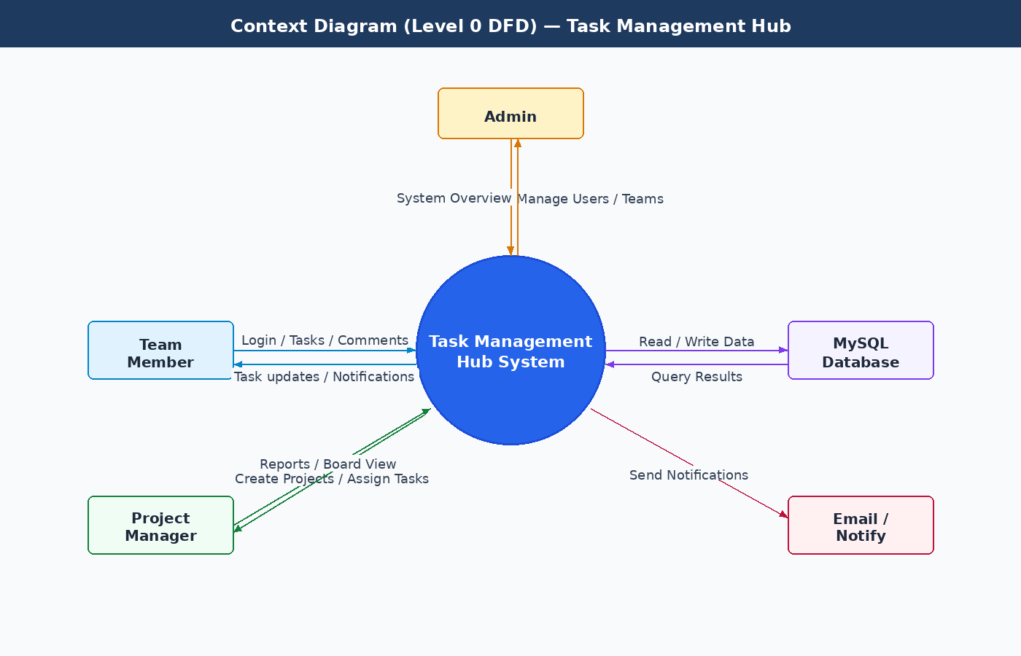
Figure 1: Context Diagram — Level 0 DFD

External Entities and Their Interactions
External Entity | Data Flowing INTO System | Data Flowing OUT of System
Team Member | Login credentials, task updates, comments, file attachments | Task board view, notifications, activity feed
Project Manager | Project creation data, task assignments, team configurations | Project boards, reports, team overview
Admin | User management actions, role changes, system settings | System overview, all user/project data, audit logs
MySQL Database | Query results, stored records | SQL queries (read/write operations)
Email / Notification Service | Delivery confirmations | Notification payloads (assignment alerts, status changes)

10.2 Level 1 DFD
The Level 1 DFD breaks the system into its seven major processes. Each process communicates with one or more MySQL data stores and receives inputs from external actors.

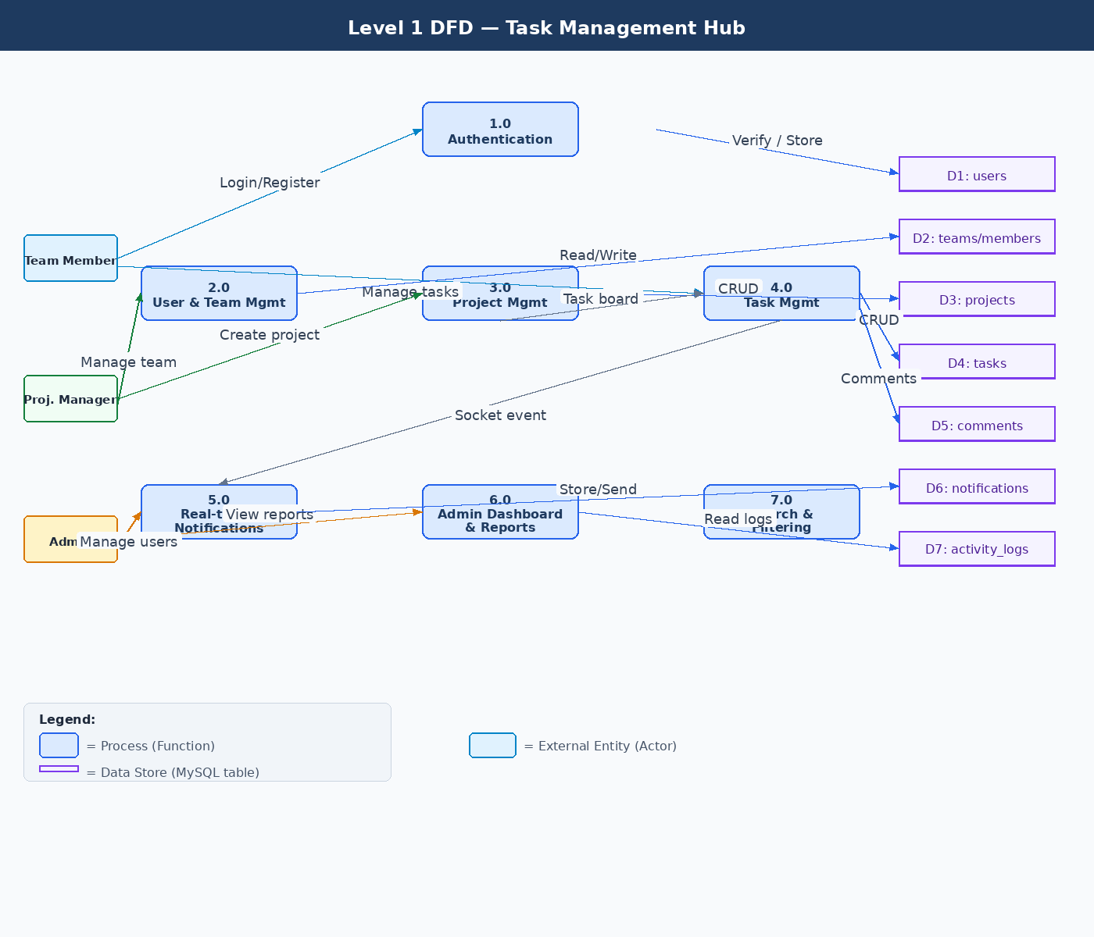
Figure 2: Level 1 DFD — Seven Major System Processes

Process Descriptions — Level 1
ID | Process Name | Inputs | Outputs / Data Stores
1.0 | Authentication | Email, password from any user | JWT token; reads/writes D1: users
2.0 | User & Team Management | User profile data, team info from Admin/Manager | Updated records in D1: users, D2: teams/members
3.0 | Project Management | Project details from Manager/Admin | Project records in D3: projects; feeds tasks to Process 4.0
4.0 | Task Management | Task data, drag events from any team member | Task records in D4: tasks, D5: comments; triggers Process 5.0
5.0 | Real-time & Notifications | Socket events from Process 4.0 | Stores D6: notifications; broadcasts via Socket.io to clients
6.0 | Admin Dashboard & Reports | Report requests from Admin | Reads D7: activity_logs, D4: tasks; returns analytics views
7.0 | Search & Filtering | Filter parameters from any user | Queries D4: tasks; returns filtered task list to frontend

Data Store Reference — Level 1
Store ID | MySQL Table | Description
D1 | users | All registered user accounts, roles, and credentials
D2 | teams, team_members | Team definitions and membership records
D3 | projects | Project records linked to teams
D4 | tasks | All task records with status, priority, assignee, and due date
D5 | comments | Comments linked to tasks
D6 | notifications | In-app notification records per user
D7 | activity_logs | Audit trail of all user actions in the system
D8 | attachments | File metadata for task attachments

10.3 Level 2 DFD — Process 4.0: Task Management
The Level 2 DFD explodes Process 4.0 (Task Management) into its seven internal sub-processes. This is the most complex part of the system, covering task creation, validation, assignment, status updates, comments, file attachments, and search/filtering.

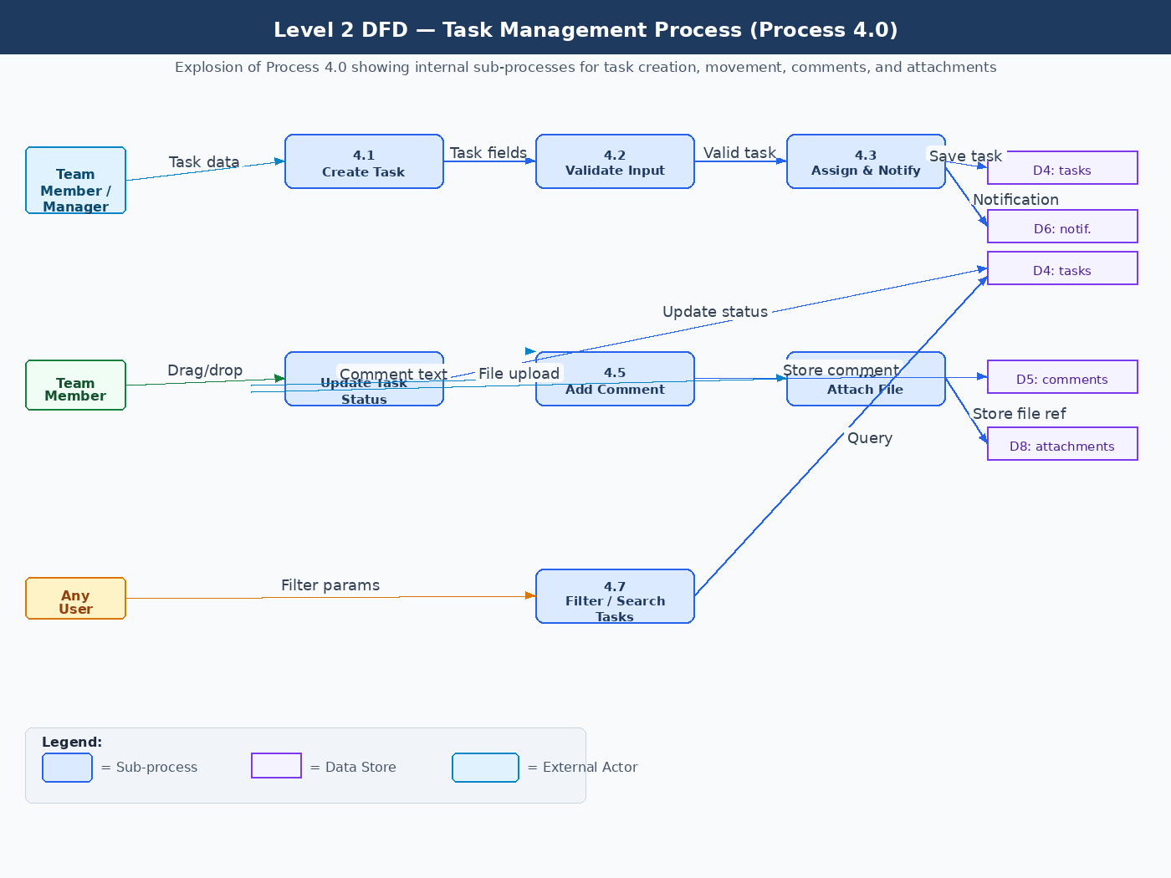
Figure 3: Level 2 DFD — Explosion of Process 4.0 (Task Management)

Sub-Process Descriptions — Level 2
ID | Sub-Process | Input Data | Output / Effect
4.1 | Create Task | Task title, description, due date, priority from Manager/Member | Passes task data to 4.2 for validation
4.2 | Validate Input | Raw task fields from 4.1 | Validated task object passed to 4.3; error returned to user if invalid
4.3 | Assign & Notify | Valid task + assignee from 4.2 | Saves task to D4: tasks; writes notification to D6: notifications
4.4 | Update Task Status | Drag-and-drop event with new column from Member | Updates status field in D4: tasks; emits Socket.io event to all board viewers
4.5 | Add Comment | Comment text + task ID from any Member | Inserts comment record into D5: comments
4.6 | Attach File | File upload from any Member (max 10MB) | Saves file to server; inserts file metadata into D8: attachments
4.7 | Filter / Search Tasks | Filter params (status, assignee, priority, date) from any User | Queries D4: tasks with WHERE clause; returns filtered task list to frontend

11. Entity Relationship Diagram (ERD)
The ERD below shows all nine MySQL tables, their columns with data types, primary keys (PK), foreign keys (FK), and the relationships between entities.

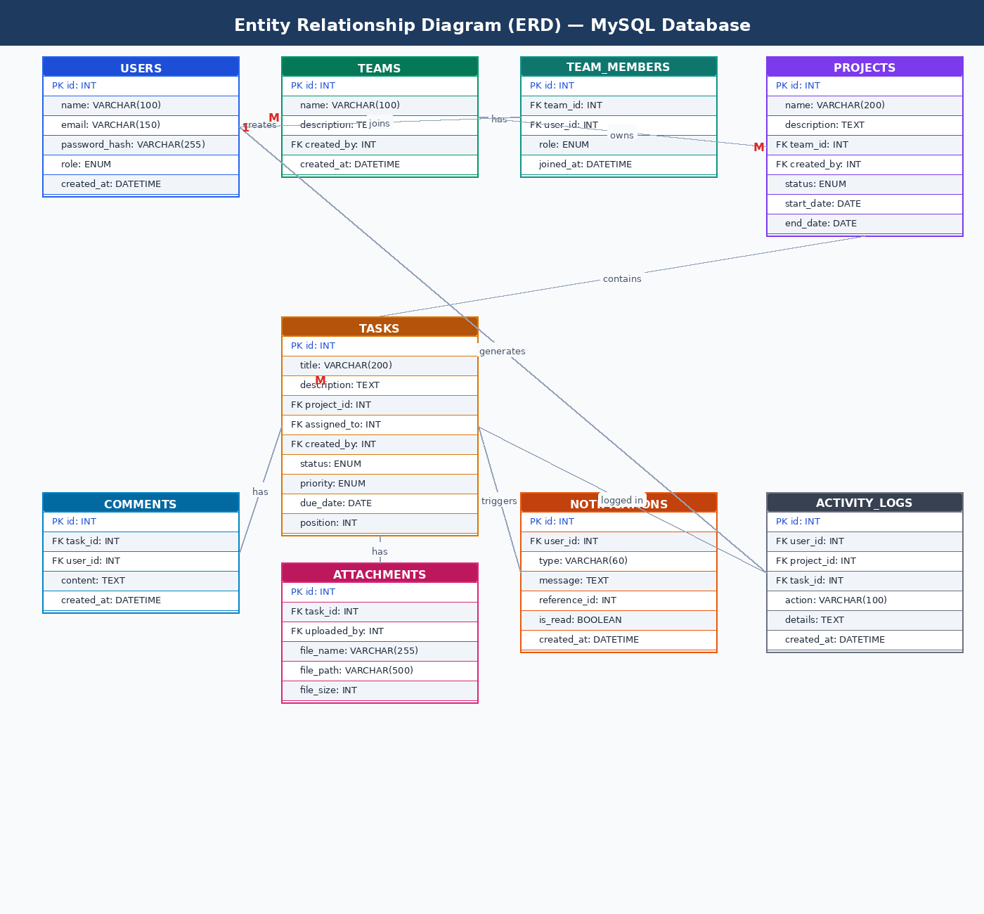
Figure 4: Entity Relationship Diagram — MySQL Schema

11.1 Entities and Attributes Summary
Entity (Table) | Primary Key / Key Columns | Purpose
users | PK: id | UNIQUE: email | Stores all system users with role (admin/manager/member) and bcrypt-hashed password
teams | PK: id | FK: created_by -> users | Defines team groups that own projects. One user can create many teams.
team_members | PK: id | FK: team_id, user_id | Junction table resolving the many-to-many relationship between users and teams.
projects | PK: id | FK: team_id, created_by | Projects belong to a team and contain a Kanban board with task columns.
tasks | PK: id | FK: project_id, assigned_to, created_by | Core entity. Holds title, description, status, priority, due date, and column position.
comments | PK: id | FK: task_id, user_id | Text comments posted on a task. Ordered by created_at ascending.
attachments | PK: id | FK: task_id, uploaded_by | File metadata for files attached to tasks. Actual files stored on the server disk.
notifications | PK: id | FK: user_id | In-app notifications per user with type, message, reference_id, and is_read flag.
activity_logs | PK: id | FK: user_id, project_id, task_id | Audit log of every significant action for the activity feed and admin reports.

11.2 Relationship Descriptions
Relationship | Cardinality | Description
users -> teams | 1 : M | One user can create many teams. teams.created_by references users.id.
users <-> teams (via team_members) | M : M | A user can belong to many teams; a team has many users. Resolved through team_members junction table.
teams -> projects | 1 : M | One team owns many projects. projects.team_id references teams.id.
projects -> tasks | 1 : M | One project contains many tasks. Deleting a project cascades to delete all its tasks.
users -> tasks (assigned_to) | 1 : M | One user can be assigned many tasks. tasks.assigned_to references users.id.
tasks -> comments | 1 : M | One task can have many comments. comments.task_id references tasks.id.
tasks -> attachments | 1 : M | One task can have many file attachments. attachments.task_id references tasks.id.
users -> notifications | 1 : M | One user receives many notifications. notifications.user_id references users.id.
users -> activity_logs | 1 : M | Every activity log entry is linked to the user who performed the action.

11.3 MySQL Foreign Key Constraints
All foreign key relationships are enforced in MySQL using FOREIGN KEY with the following ON DELETE rules:
- tasks.project_id -> projects.id ON DELETE CASCADE
- comments.task_id -> tasks.id ON DELETE CASCADE
- attachments.task_id -> tasks.id ON DELETE CASCADE
- team_members.team_id -> teams.id ON DELETE CASCADE
- notifications.user_id -> users.id ON DELETE CASCADE
- activity_logs FK columns use ON DELETE SET NULL to preserve logs after entity deletion

Appendix A: Revision History
Version | Date | Author | Changes
1.0 | May 2026 | Jean Pierre Ndikumana | Initial draft — full SRS created for internship project submission
1.1 | May 2026 | Jean Pierre Ndikumana | Added Section 10 (DFDs: Context, Level 1, Level 2) and Section 11 (ERD with full MySQL relationship tables)

Appendix B: Document Approval
Role | Name | Signature / Date
Developer | Jean Pierre Ndikumana | ________________________
Supervisor / Reviewer |  | ________________________
Date of Approval |  | ________________________

End of Software Requirements Specification Document
Team Collaboration & Task Management Hub — Jean Pierre Ndikumana — Version 1.0

